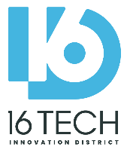

Kokosing Construction Company, Inc. is seeking City Certified XBE (MBE, WBE, VBE, and DOBE) Companies, Vendor & Suppliers for the

**16 TECH - TREE CLEARING PROJECT** (in preparation for upcoming Bridge Project)

Pre-Bid Meeting: Oct 13, 2021: 9 AM

Meeting link: <https://us02web.zoom.us/j/83748051013?pwd=amhZb1lpbERBQ05uWXdxNC9HOHJlQT09>

Bid Documents Released Oct 8, 2021

Bids Due Oct 22, 2021

Contract Award Early Nov 2021

Construction: Erosion Control Mid-Nov 2021

Construction Clearing & Grubbing Dec 2021

All bidders should contact Jim Elchert to access to bid documents and to submit questions: email: [jpe@kokosing.biz](mailto:jpe@kokosing.biz), phone: 614-228-1029.

Bid Packages:

1. Clearing & Grubbing
2. Erosion Control
3. Temp Seeding / hydroseed

This work is in preparation for the 16 Tech Bridge and Dependent Road Projects Work, expected to be released in January 2022. Diversity Outreach Events will be coming soon!